

SUSTAINABILITY DIVISION

Research, Testing and Development

CONFIDENTIAL

|  |  |  |
| --- | --- | --- |
| Title | : | Progress report 1 |
| Date Compiled | : | 25 November 2016 |
| Report No | : | One |
| Revision | : | January 2017 |
| Mentor | : | Emanuel Netshivhulana |
| Author | : | Thuso Phatswane |
| Section | : | Renewable Technologies |

Copyright of this report is reserved. No publication or dissemination of its contents is allowed without written permission.

**Abstract**

This document details the entire site work visit that has been covered on different Eskom power stations, Lethabo, Matla and Kendal. All the site work visits were done within a month of November 2016. The purpose of this was to give the Electrical Engineering students P1 & P2 exposure to the photovoltaic plant, thermal plant as well as how the Eskom rules apply in these different stations. The procedures required to perform operations and maintenance activities on Solar Photovoltaic (PV) plants have been further explained in this document. As in any power plant a PV plant requires regular maintenance to ensure that the availability and performance of the plant is maximised. The Rosherville photovoltaic power plant is a 400 KW (DC) that consist of two types of modules which are Thin Film and Polycrystalline. The combined electrical power output from all the inverters, total to 360 kW AC. The maintenance of PVs at Rosherville started on the 3rd of November 2016. At Kendal the team also did maintenance on the ABB 11KV PV inverter transformer feeder, which took about 4 hours on maintenance. That was part of the training plan for the team, an exposure to circuit breaker protection. The group also went to Lethabo for maintenance in wiring the string cables using MC4 connectors with 1000V insulated tools, which was beneficial to every individual in a team to be exposed to a bit of hand tool skills. At Matla power station the team performed the STEP test (steam, temperature, energy and pressure) for determining the efficiency of a boiler as there was a leakage on a boiler at unit two. The cooperation among all the colleagues was highly professional with zero harm to anyone.

Contents

Abstract 2

Section one: PV plants 4

Introduction 4

Kendal PV plant 5

Rosherville PV plant 7

Lethabo power station 8

Section two: Matla power station 10

**Table of figures**

Figure 1Commonly used solar modules 4

Figure 2 11 KV inverter transformer 5

Figure 3Type of tools used 6

Figure 4 Undervoltage coil 7

Figure 5 Undervoltage coil fuse 8

Figure 6 MC4 connectors 8

Figure 7 MC4 connectors crimping tools 9

Figure 8 pitot tubes 11

Figure 9 Thermocouple meter 11

Figure 10 Thermocouple 12

**Section one: PV Plants**

**Introduction**

There are six solar photovoltaic (PV) sites currently operating with an installed capacity of 2 500 kilowatts (KW). The renewable technologies is one of the section under the sustainability division in Eskom. The purpose of this section is to add value to the business from research, testing and development. They are located at the Kendal power station in Mpumalanga, Lethabo power station in the Free State, Eskom’s offices in Rosherville (Johannesburg), Sunilaws (East London) and two at head office Megawatt Park (Johannesburg) - one on the rooftop and one on the carports. A photovoltaic (PV) plant transforms solar energy directly and instantaneously into electrical energy (DC current and voltage). A photovoltaic cell or photocell is an electrical device that converts the energy of light directly into electricity by the photovoltaic effect. A photovoltaic panel or module comprises of a number of individual photovoltaic cells, sandwiched between layers of glass, and packaged together with a plastic or metal backing and edging. A photovoltaic array (also called a solar array) consists of multiple photovoltaic modules that are connected (strung) together. The modules in a PV array are first connected in series to obtain the desired voltage. The individual strings are then connected in parallel to allow the system to produce more current. Figure 1 shows the 3 types of PV panels; monocrystalline, polycrystalline and armorphous thin film. Monocrystalline are the most expensive but also the most efficient (14-19%). They are the most reliable solar PV panels in terms of life expectancy. Polycrystalline are cheaper but are slightly less efficient (10-16%). Therefore more PV panels are required for the same wattage compared to the monocrystalline type. Amorphous thin-film is the cheapest and the least efficient (6-8%), requiring approximately double the amount of panels compared to the monocrystalline type.

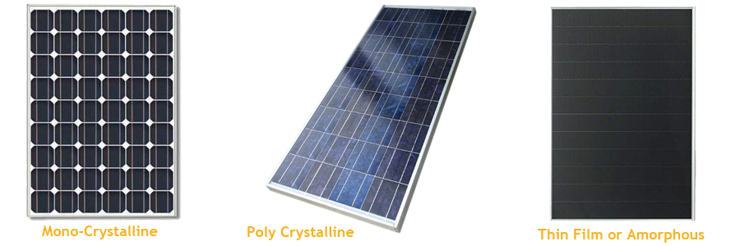

Figure 1Commonly used solar modules

**The main advantages of photovoltaic (PV) plants can be summarized as follows**:

1. Can be located wherever there is sunlight and adequate space
2. Does not pollute the environment with emissions
3. Since the basic plant does not have moving parts the reliability of the plant is high.
4. ) Operating and Maintenance (O&M) costs are low compared to other types of generation plants
5. The system design is modular

**The main disadvantages of photovoltaic (PV) plants can be summarized as follows:**

The main disadvantage of PV is that the generation of power is erratic due to the variability of the solar energy source and furthermore no generation is possible at night (low light level. During low light levels the voltage output of the PV modules decreases.

**Inverters**

The main function of an inverter located in a PV plant is to convert the DC output of the PV array to AC. There are 3 types of inverters namely:

1) Micro inverters- A micro inverter consists of a small box located on the back of or situated very close to every solar panel. Therefore the conversion of DC to AC is done at the panel level. The power output of a micro inverter is typically between 200W and 300W.

2) String inverters- A string inverter is installed for layouts which incorporate string connections of PV panels. The amount of PV modules in a string will vary usually between 17 to 20 panels depending on the input DC voltage of the inverter. String inverters are commonly available in the following sizes 3kW, 4kW, 5kW, 15kW, 17kW and 20kW.

3) Central inverters- Central inverters are used for commercial and utility scale PV installations. Central inverters are available from 100kW upwards.

**Kendal (Mpumalanga)**

On the 9th of November 2016 there was a problem with the tripping of an 11kv circuit breaker at Kendal near Kriel in Mpumalanga. Figure 2 shows the ABB 11kv inverter transformer feeder.

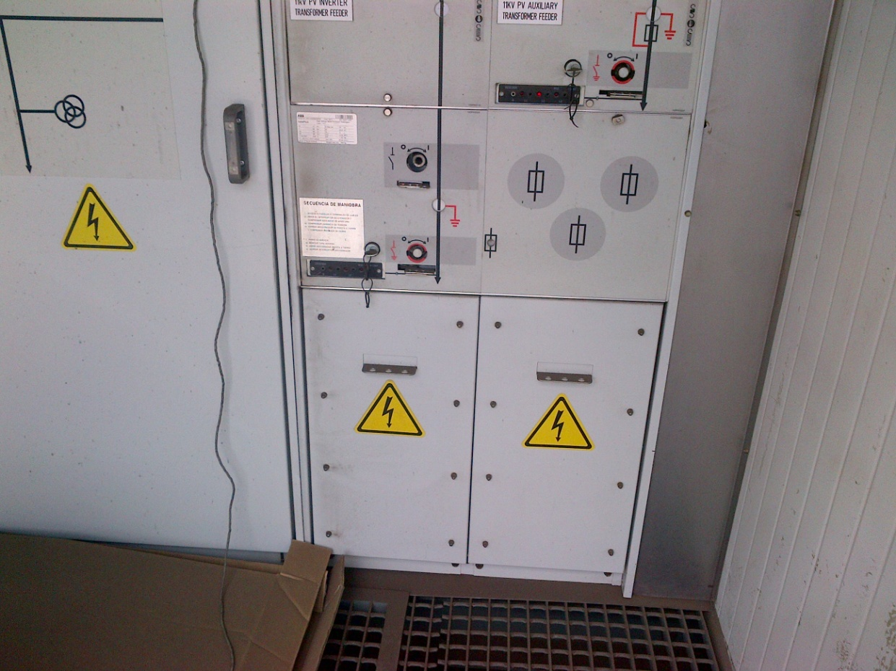

Figure 2 11 KV inverter transformer

## Aim

The aim was to keep the PV plant operating by charging the spring manually inside the 11KV circuit breaker and to understand why it’s not charging automatically. To understand how a meter can capture data of electrical power produced on high voltages.

* 1. **Equipment Used**

Figure three shows the type of tools that were used in Kendal on the 11 kv inverter transformer feeder.



Figure 3Type of tools used

Clamp-on Ammeter (AC/DC)

**1.3 Methodology**

This covers the methodology followed during the charging of the spring at Kendal PV plant.

The group had a work permit before entering the plant.

Fault finding on a switch gear using the control room manual and apparatus.

Asked for the operator’s confirmation after fault findings.

Then they checked the output of the plant.

**1.4 Results**

The spring was charged using the spring charger.

The group recognised that, the same methodology has to be followed if the spring discharges again.

The group followed the Eskom life saving rule before working (open, isolate, test, earth, bond, and/or insulate before touch).

**1.5 Conclusion**

The plant was then operating after was charged. The fault that led to 11KV PV inverter to trip was excessive current passing through it. Voltages above 11KV and current above 100A cannot be measured using a meter, therefore voltage and current transformer has to be used for stepping down voltage to 110V and 1A current in order to capture data from the meter.

**Rosherville PV plant**

**2.1 Aim**

The aim was to find out why the under-voltage coil got burned and to keep the PV plant operating by replacing the burnt under voltage coil and the fuse with the new ones of the same ratings. Figure 4 below shows the inner view of the burnt coil.

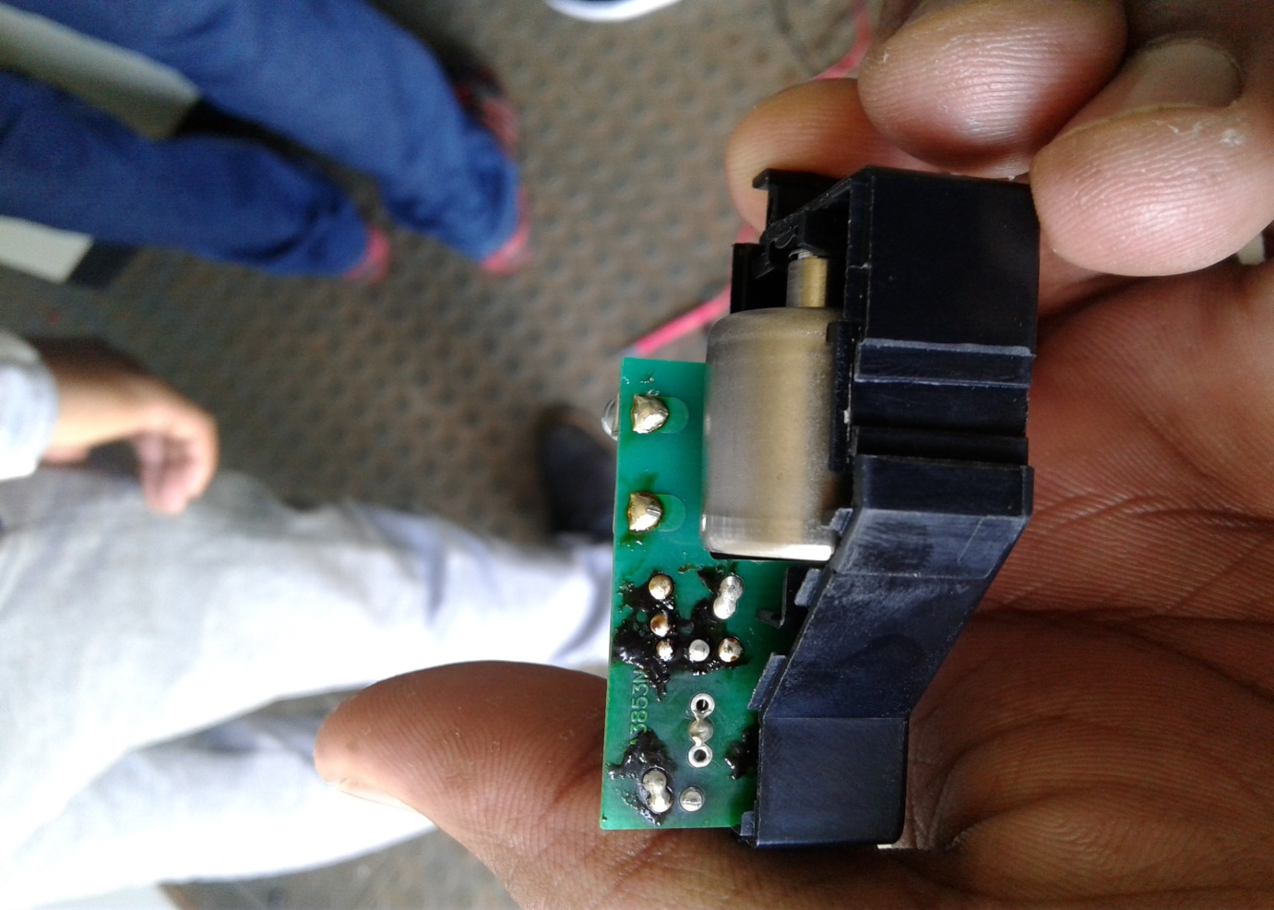

Figure 4 Undervoltage coil

**2.2 Apparatus**

Flat screw driver

Clamps for wire

Clamp-on Ammeter (AC/DC)

Long nose plyer

**2.3 Methodology**

This is methodology that has been followed at Rosherville PV plant during the replacement of the burned under-voltage coil and the fuse.

The group checked the circuit diagram of the control room, because they needed to understand the wiring inside.

Then performed test for continuity to determine where the fault was, as Eskom rule applies (isolate, test before touch).Then after getting a fault they switched off the breaker before dismantling the burned components in order to be replaced.

**2.4 Results**

There was an excessive current coming from the PV plant to the circuit breaker which led to the burning of components. The new under-voltage coil with a fuse was replaced inside a circuit breaker. The group experienced no hazards during maintenance. Figure 5 below shows the burnt 2A undervoltage coil fuse.

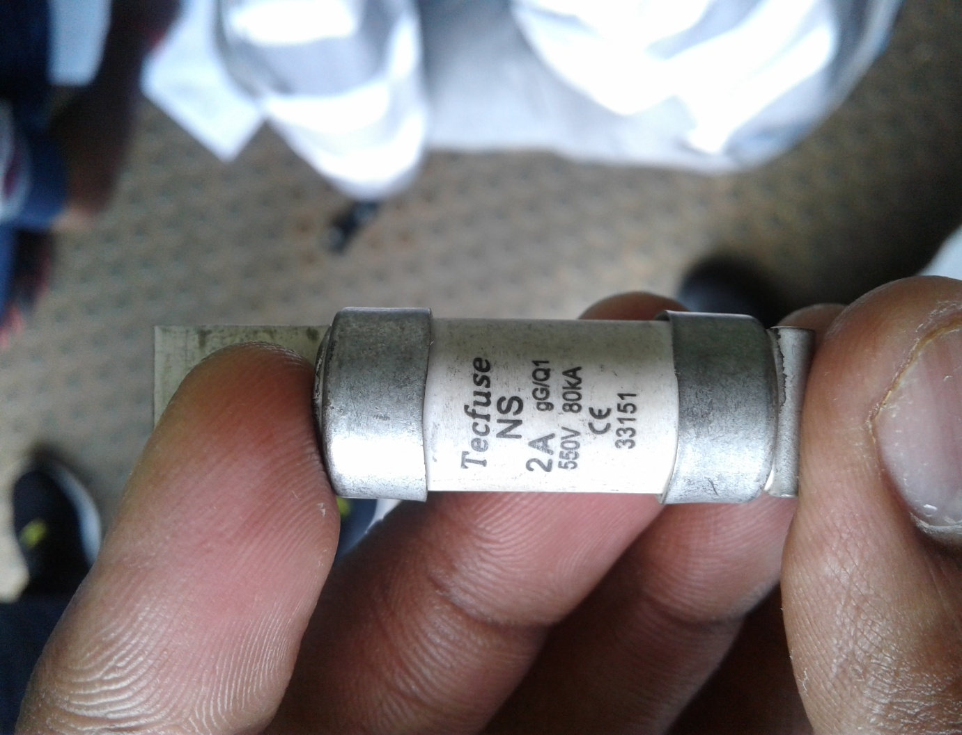

Figure 5 Undervoltage coil fuse

**2.5 Conclusion**

The components were replaced with no further damage to the circuit, with all procedures being followed. Thus, the group decided to do further investigation concerning the excessive current that burned these two component.

**Lethabo Power Station**

On the 25th of November 2016 we went to Lethabo power station. The picture below shows the replaced MC4 connectors as the older ones got burnt.

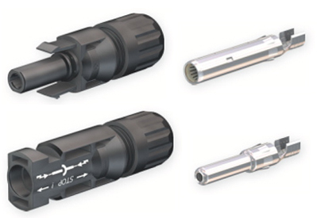

Figure 6 MC4 connectors

3.1 Aim

The aim was to check why one of the strings is not giving electric power (direct current) to the plant and find out why the hydraulic actuator arm was not responding to the tracker control pump.

**3.2 Apparatus**

Figure 5 shows the MC4 connectors crimping tools

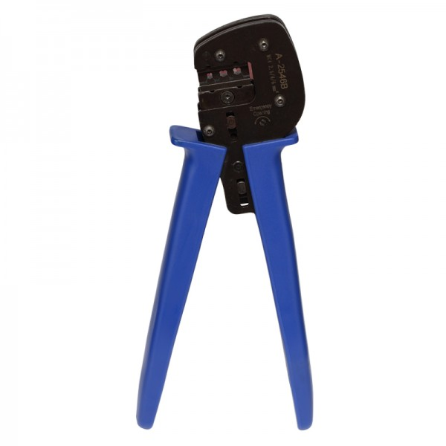

Figure 7 MC4 connectors crimping tools

Long nose plyer

Clamp-on Ammeter (AC/DC)

**3.3 Methodology**

Asked for work permit before work.

Tested the current in all the wires in a combiner box as Eskom rule applies, then checked the tracker control pumps whether they are working or not.

Then replaced burned MC4 connectors with new ones.

The group had to then check the electrical output power from the strings.

Results

The group had replaced the MC4 connectors according to the connections in a control room manual.

The hydraulic actuator arm in one of the other strings was still not operating even when the tracker control pump was supplying oil to it.

**3.5 Conclusion**

The plant started to operate with no further damages to MC4 connectors. Problem that needed further investigations was to check why the hydraulic actuator arm still not operating even if its oil is pumped to it.

**Section two: Matla Power Station (Boiler efficiency test)**

**Introduction**

This report covers the work that has been done at Matla Power Station, STEP (steam, temperature, energy and pressure) test at 580MW which was on the 15th of November 2016, then 600MW on the 16th performing same test. The section that the test was based was on unit two, economizer, where we had to test for temperature and flue gases from combustion to analyze the efficiency of the boiler. It can be done only if the unit is running. All apparatus were used as named below.

A pitot tube was used to determine the gas flow velocities in the boiler along with a thermocouple attached. In boilers, economizers are heat exchange devices that heat fluids, usually water, up to but not normally beyond the boiling point of that fluid. Flue gas temperature is an indication of how effectively combustion heat is being transferred to the boiler water. In general, lower flue gas temperature indicates better heat transfer and higher overall efficiency. It means that less energy is going up the stack and, everything else being equal, more is going into the water. If you find flue gas temperature gradually increasing over time, this indicates gradually deteriorating heat transfer within the boiler. This could be caused by soot build up on the fire side of the heat transfer surfaces, or scale build up on the water side.

A common application of economizers in steam power plants is to capture the waste heat from boiler stack gases (flue gas) and transfer it to the boiler feed water. This raises the temperature of the boiler feed water, lowering the needed energy input, in turn reducing the firing rates needed for the rated boiler output.

**4.1 Aim**

The aim of the test was to determine the efficiency of a boiler by analysing the flue gases on the economizer and to understand why a boiler has leakage.

**4.2 Apparatus**

Pitot tube-a pressure measurement instrument used to measure gas flow velocity

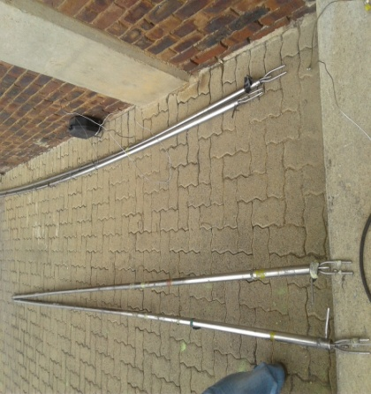

Figure 8 pitot tubes

Thermocouple meter – A meter used to measure the temperature

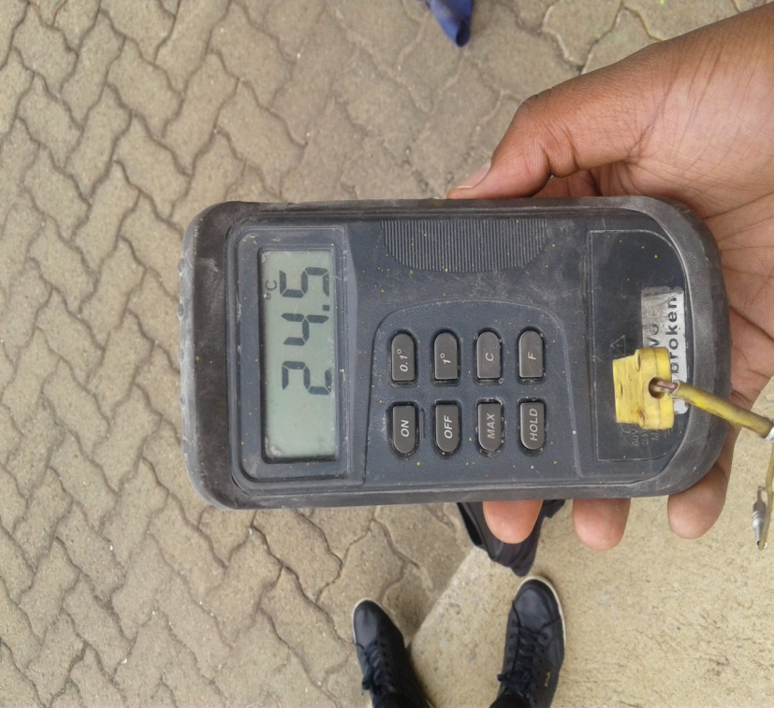

Figure 9 Thermocouple meter

Thermocouple - Is an electrical device consisting of two different conductors forming two electrical junctions at different temperature.

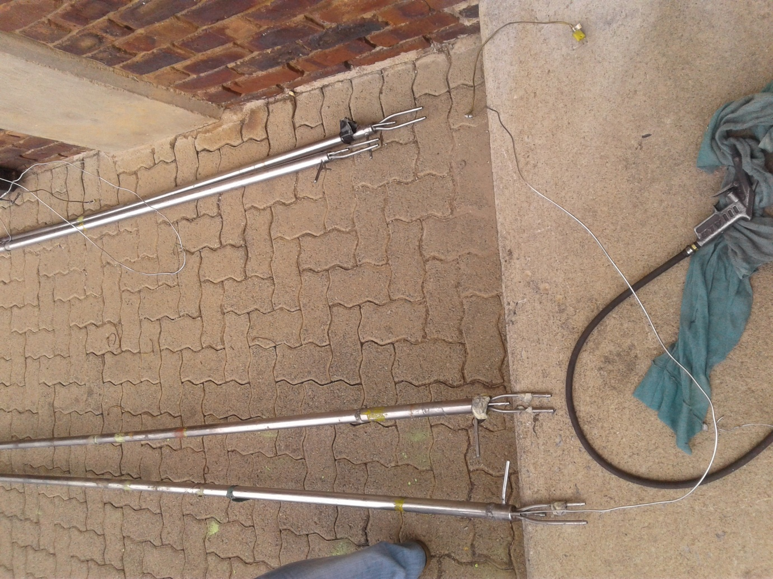

Figure 10 Thermocouple

* Vice grip- A plyer that can be locked into position using an over-centre action.
* Wire for earthing a pitot tube- A wire used to protect static shocks from the Pitot tube.

**4.3 Methodology**

The group checked if unit two was operating at (580 MW of electric power, AC).

There was a supervisor to lead the team.

The group checked all the hazards surrounding them near the economizer and write them down and signed a register for that.

Opened the ports, insert the pitot tubes and test in different heights as shown in the form.

They kept on testing different ports to compare with other side of the economizer.

Each and every time they changed ports during test, the time was recorded. Therefore same test was performed the following day at (600 MW of electric power, AC)

**4.4 Results**

All the data at the economizer was recorded accordingly. A minimum of three people among the group in every sections for this test were needed to bring up more accuracy in a test, and work can be done in time. Calculations still need to be published.

**4.5 Conclusion**

The boiler efficiency test was performed because of the boiler leakage. All the recorded values were taken for the final calculations to check the value of efficiency. The formula for calculating the efficiency is, (η = Output / Input), where: η – Is for efficiency. It’s important to look at the efficiency of the boiler itself, because there are also a number of environmental factors that can affect boiler operation. Addressing them is often more manageable and less capital intensive than considering new equipment.